**Challenge task 1**

1. **Launch one ec2 instance using amazon linux 2**

**Open AWS Console → EC2 → Launch Instance**

AMI: Amazon Linux 2 (64-bit x86)

Instance type: t2.micro (for free tier)

Key pair: create or select existing

Security group: allow 22 (SSH), 80 (HTTP), 8080 (Tomcat/Jenkins), 443 (HTTPS)

Launch instance.

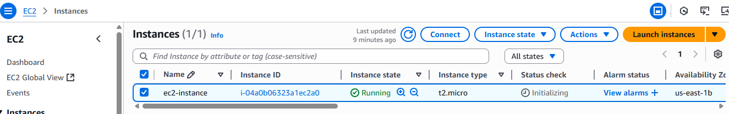

**SSH into the instance:**

ssh -i your-key.pem ec2-user@<EC2-Public-IP>

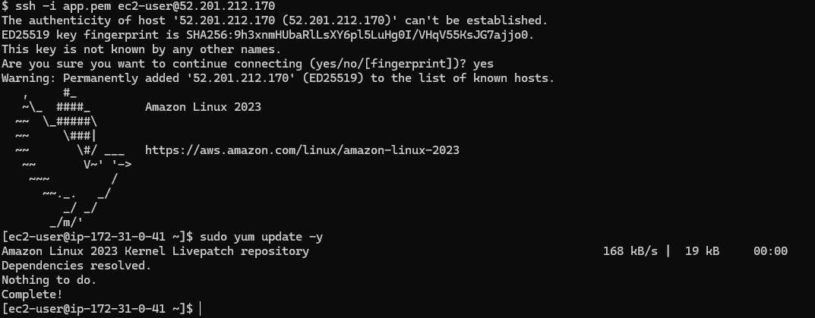

1. **Install Docker**

sudo yum install -y docker

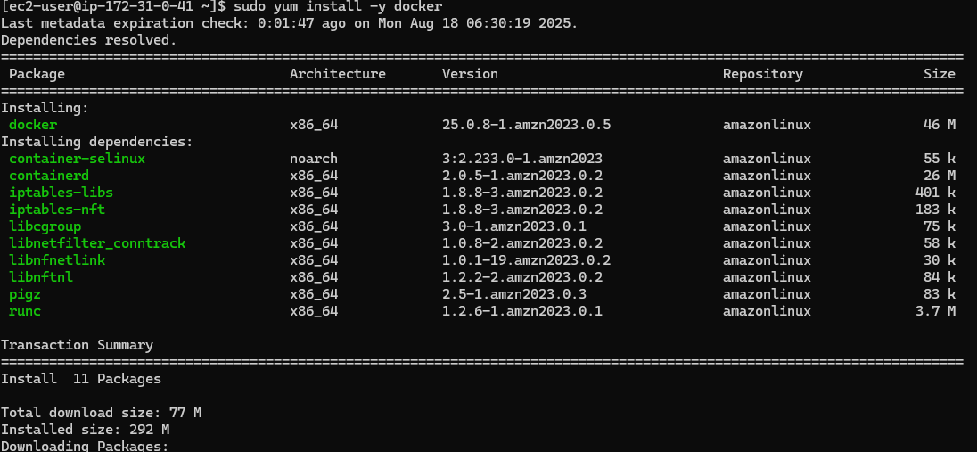

sudo systemctl start docker

sudo systemctl enable docker

sudo usermod -aG docker ec2-use**r**

sudo systemctl status docker

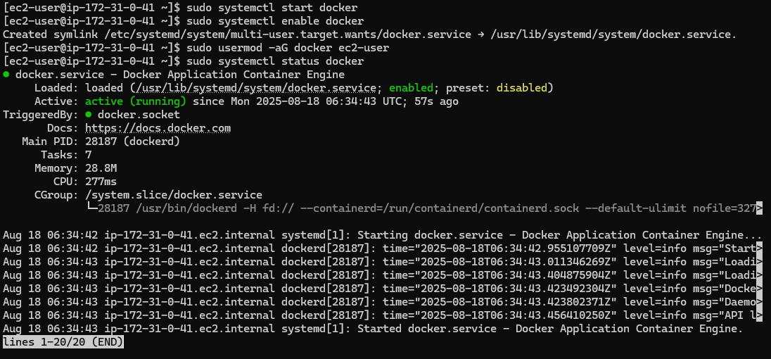

1. **Install jenkins**

To install java

sudo yum install -y java-17-amazon-corretto

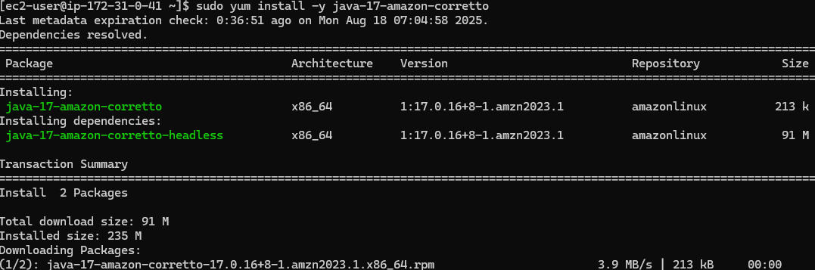

To check java version

java -version



sudo wget -O /etc/yum.repos.d/jenkins.repo \https://pkg.jenkins.io/redhat-stable/jenkins.repo

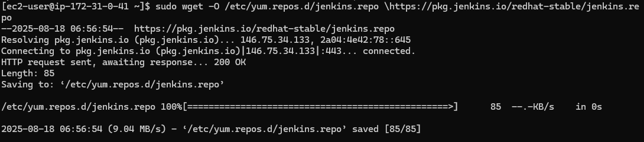

sudo rpm --import https://pkg.jenkins.io/redhat-stable/jenkins.io-2023.key

sudo yum install -y jenkins

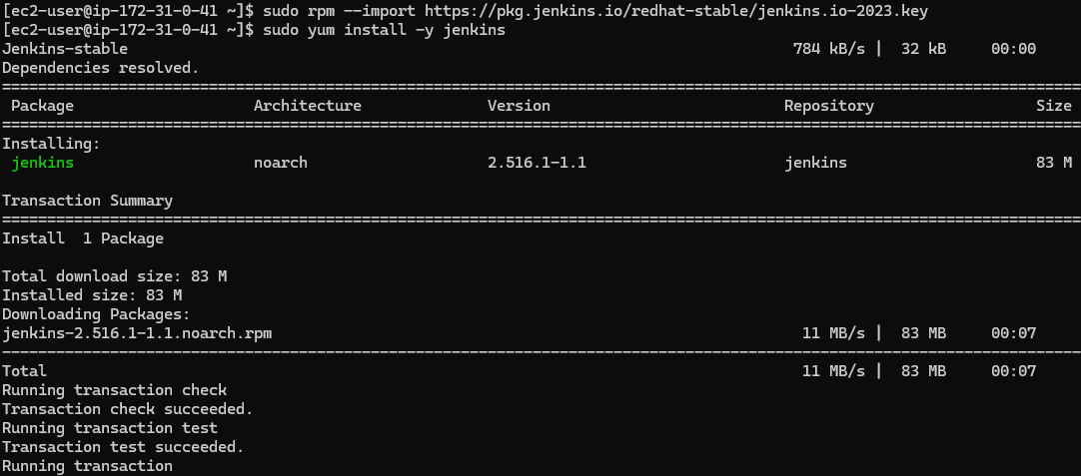

sudo systemctl enable jenkins

sudo systemctl start jenkins

sudo systemctl status jenkins

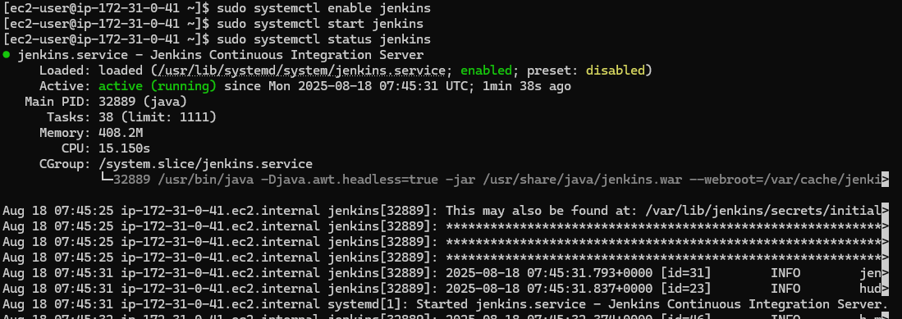

Go to check the browser

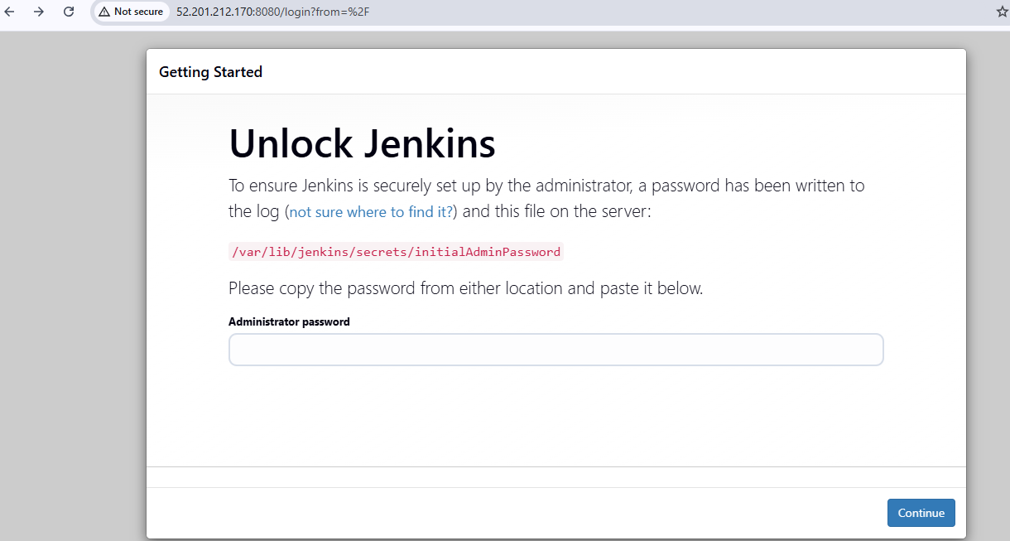



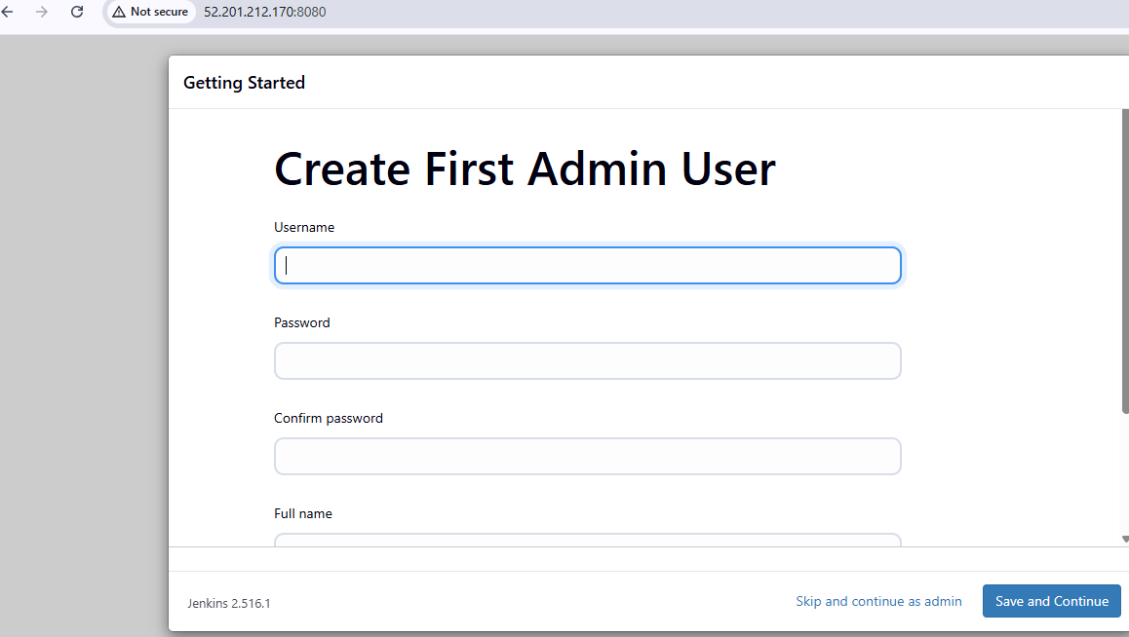

1. **Install apache**

sudo yum install -y httpd

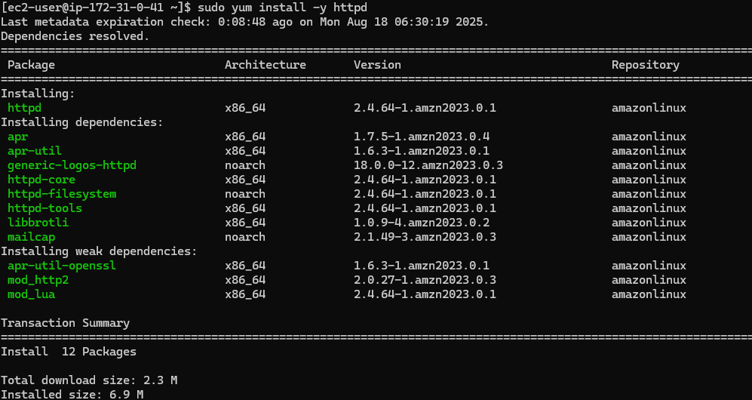

sudo systemctl start httpd

sudo systemctl enable httpd

sudo systemctl status httpd

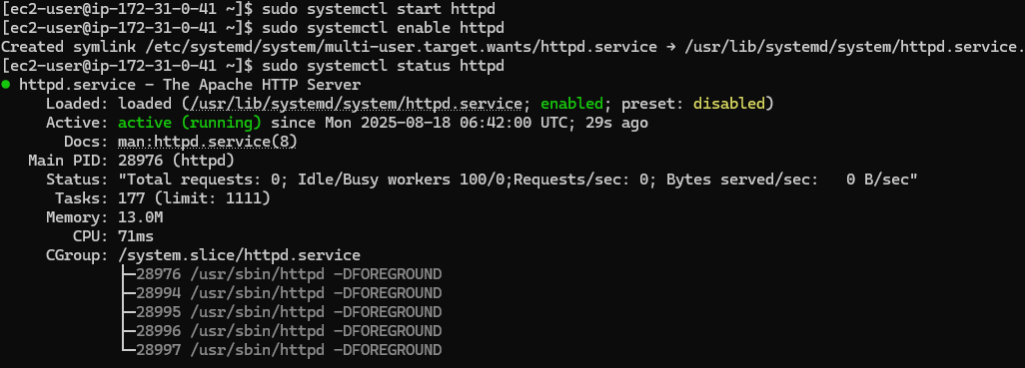

1. **Install nginx**

sudo yum install -y nginx

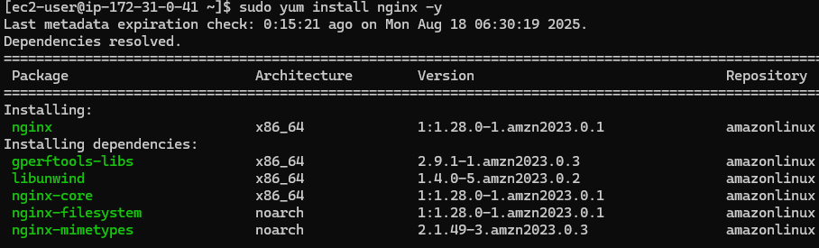

sudo systemctl start nginx

sudo systemctl enable nginx

sudo systemctl status nginx

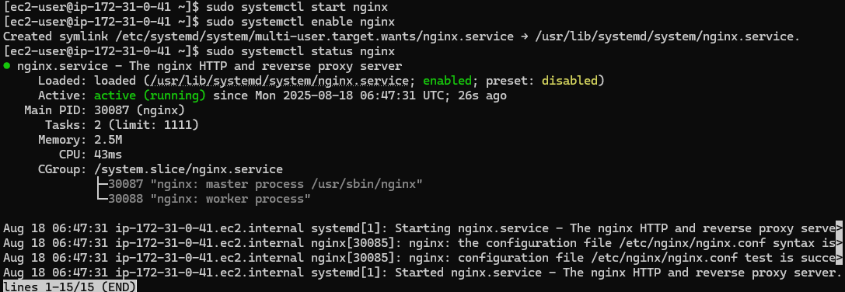

1. **Install Apache Tomcat**

cd /opt

sudo yum install -y wget tar

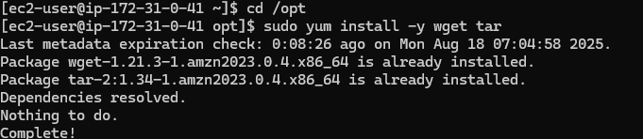

Sudo wget <https://dlcdn.apache.org/tomcat/tomcat-11/v11.0.10/bin/apache-tomcat-11.0.10.tar.gz>

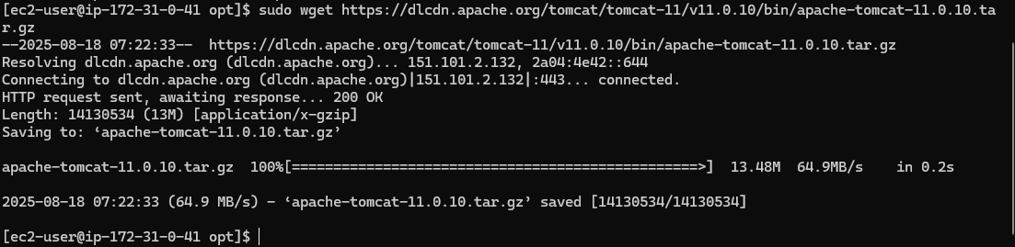

sudo tar xvf apache-tomcat-11.0.10.tar.gz

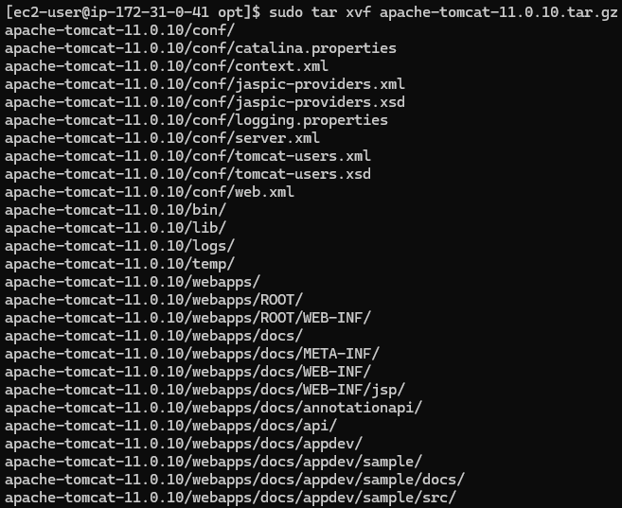

sudo mv apache-tomcat-11.0.10 tomcat11



cd tomcat11

cd /bin

sudo chmod +x *.sh

sudo ./startup.sh

